**Photos of participants during the consultative meetings**

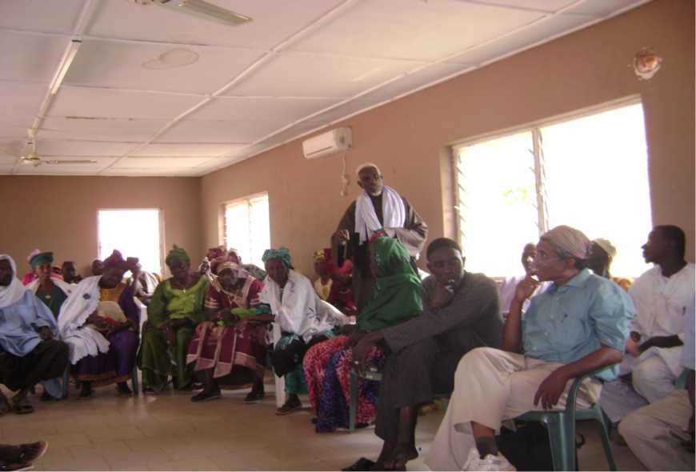

Photo 1: Meeting held at Sapu, Central River Region, for farmers representatives

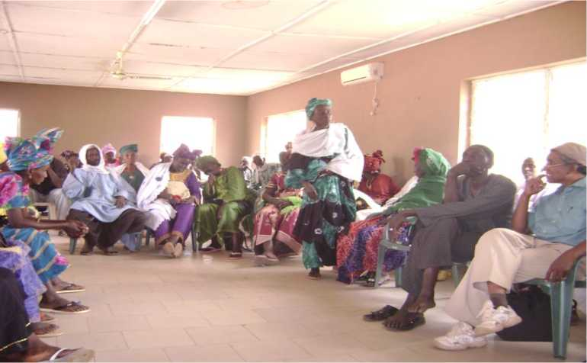

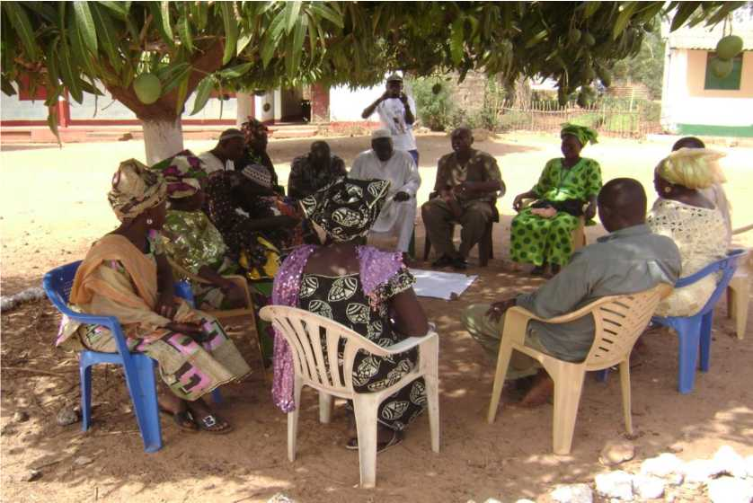

Photo 3: Group Discussions during the consultative meeting

